Sprint 1 Reflection

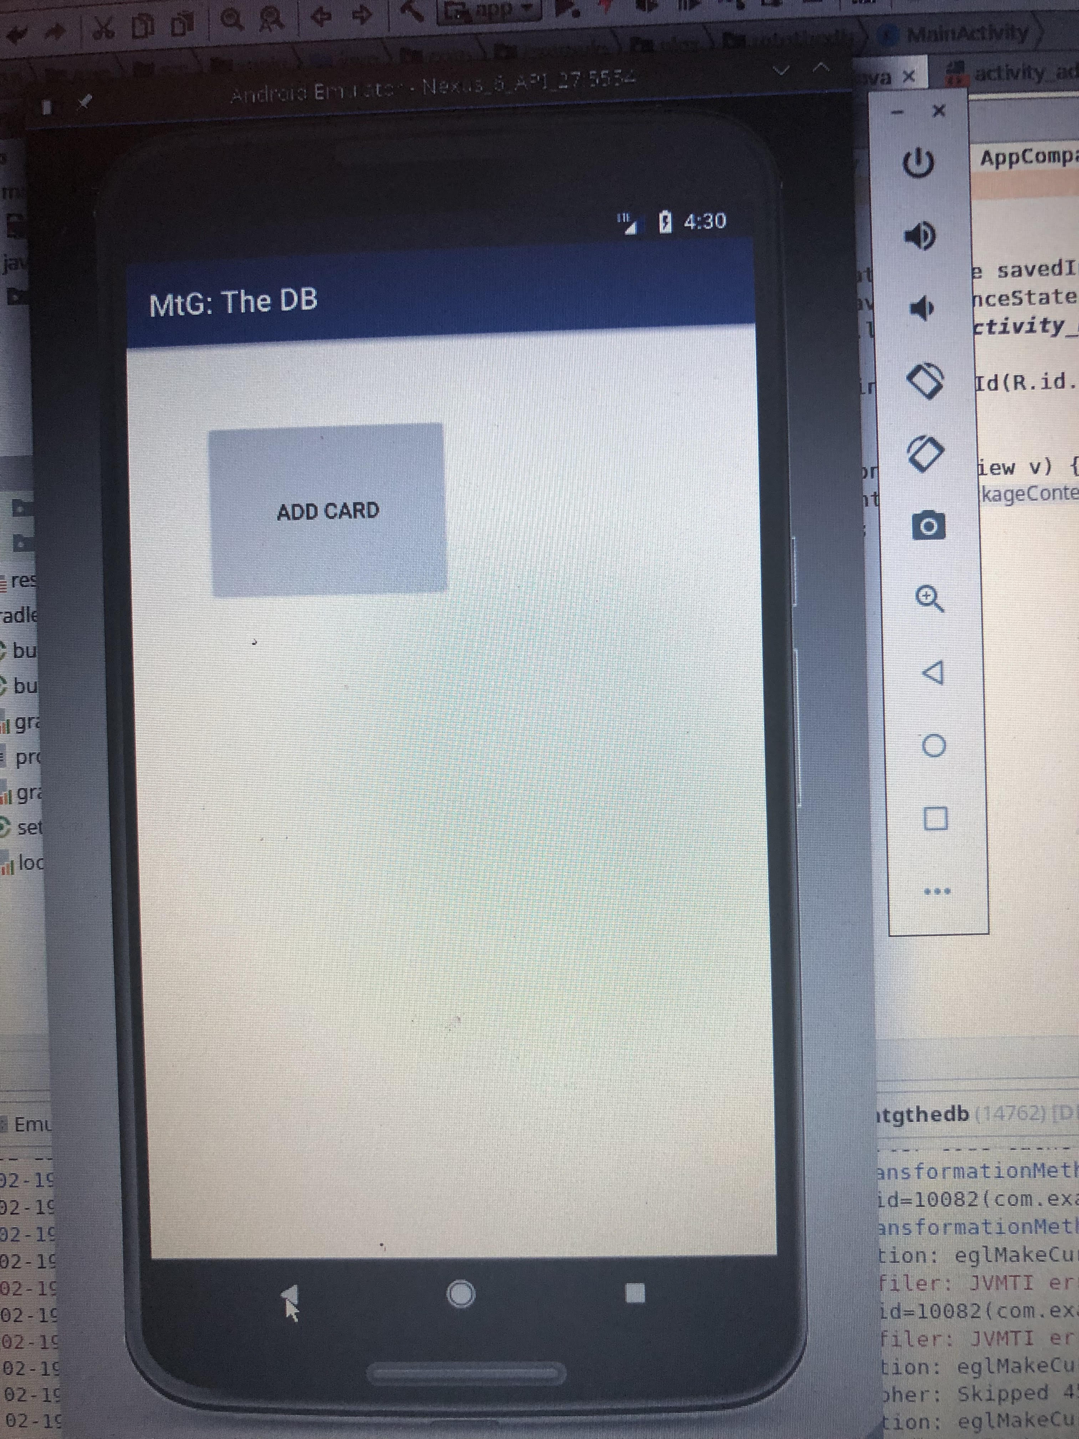**Added features:** Add Card Button to home screen

Implement Add Card Feature

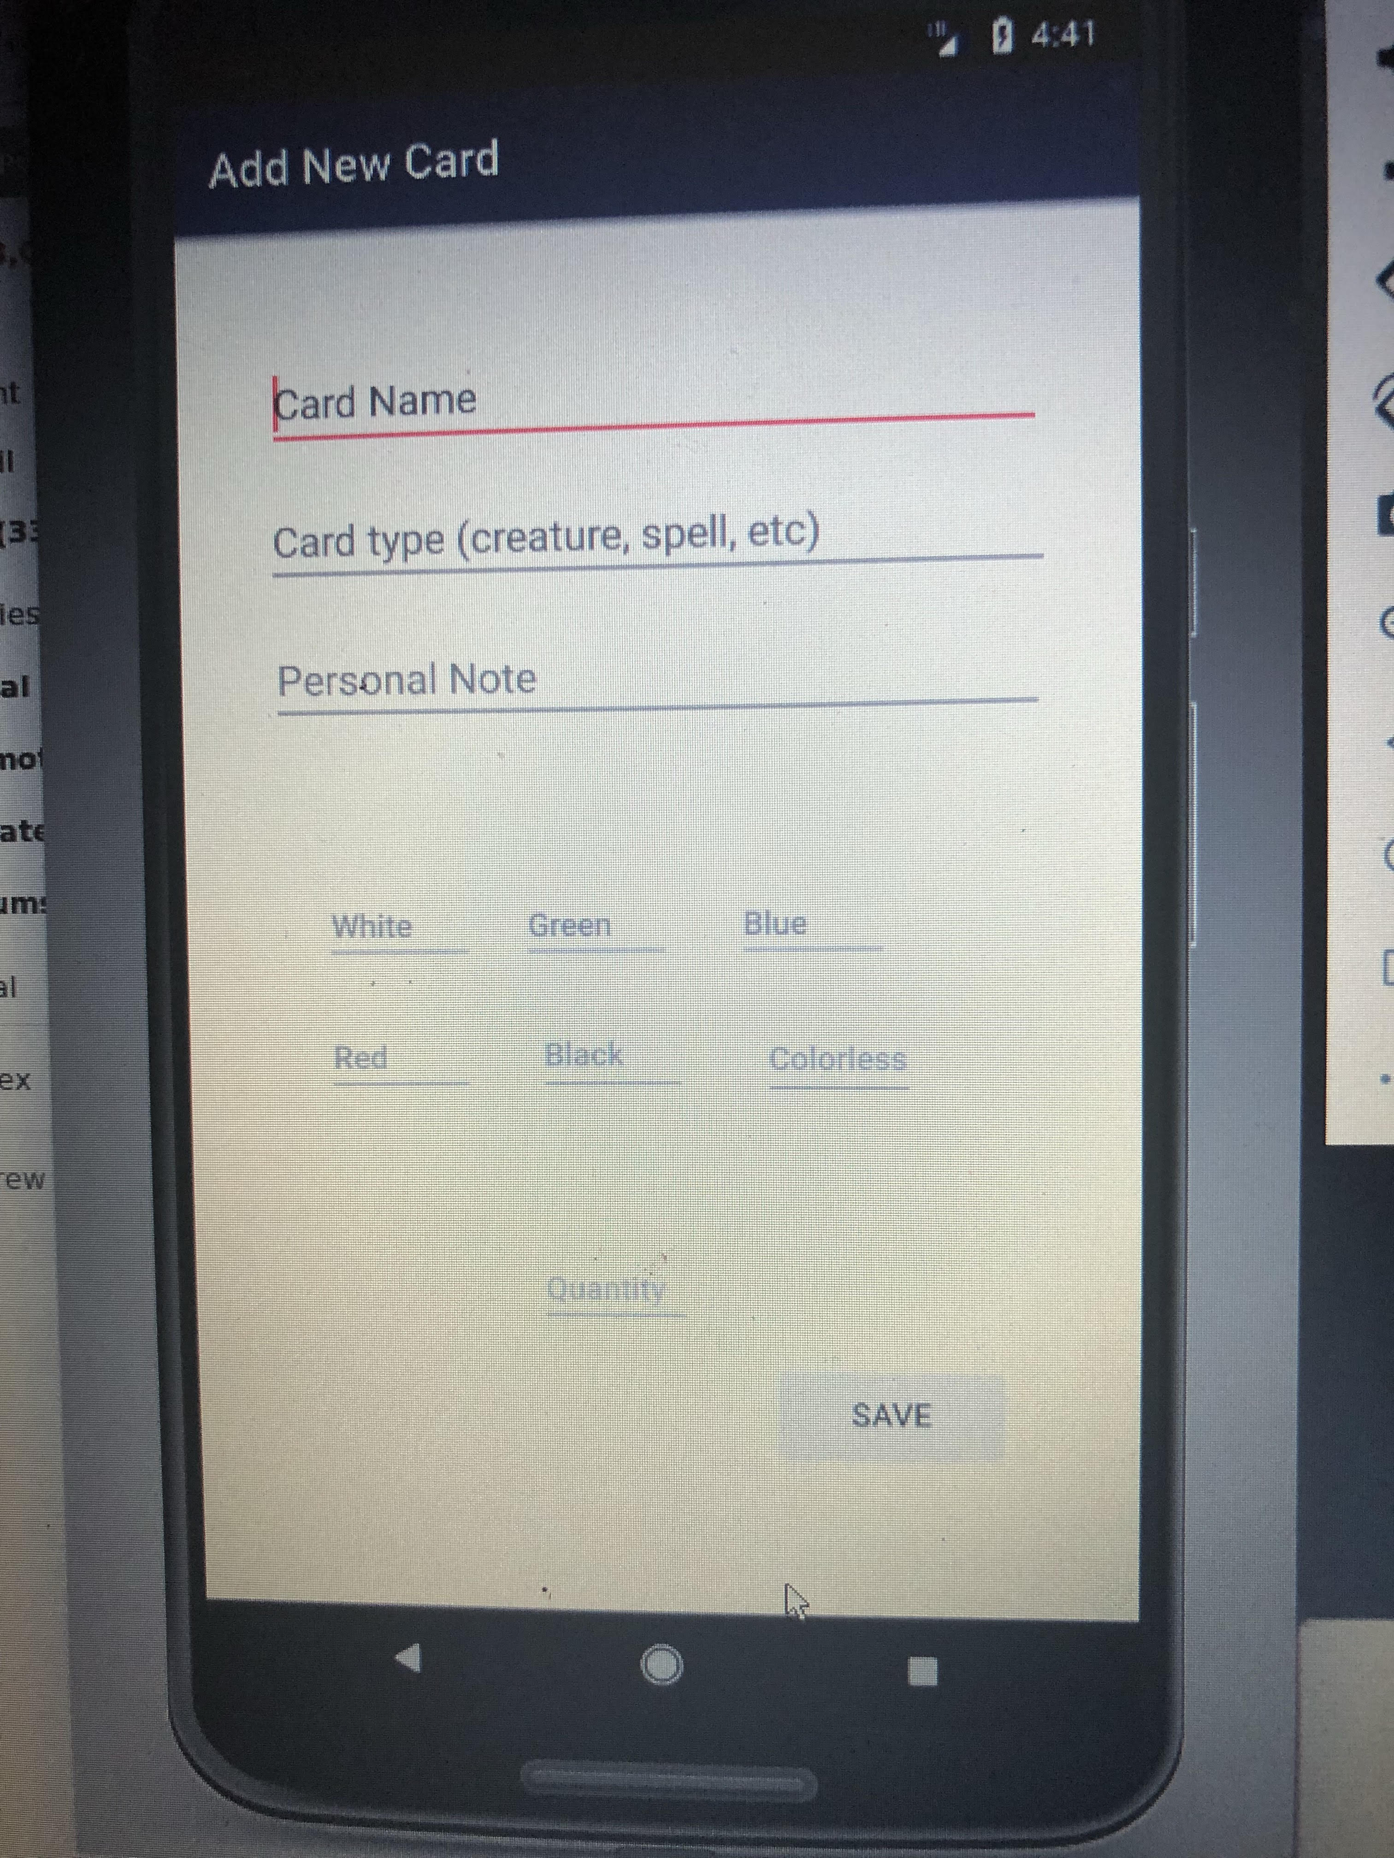

Show user input data on pushing save

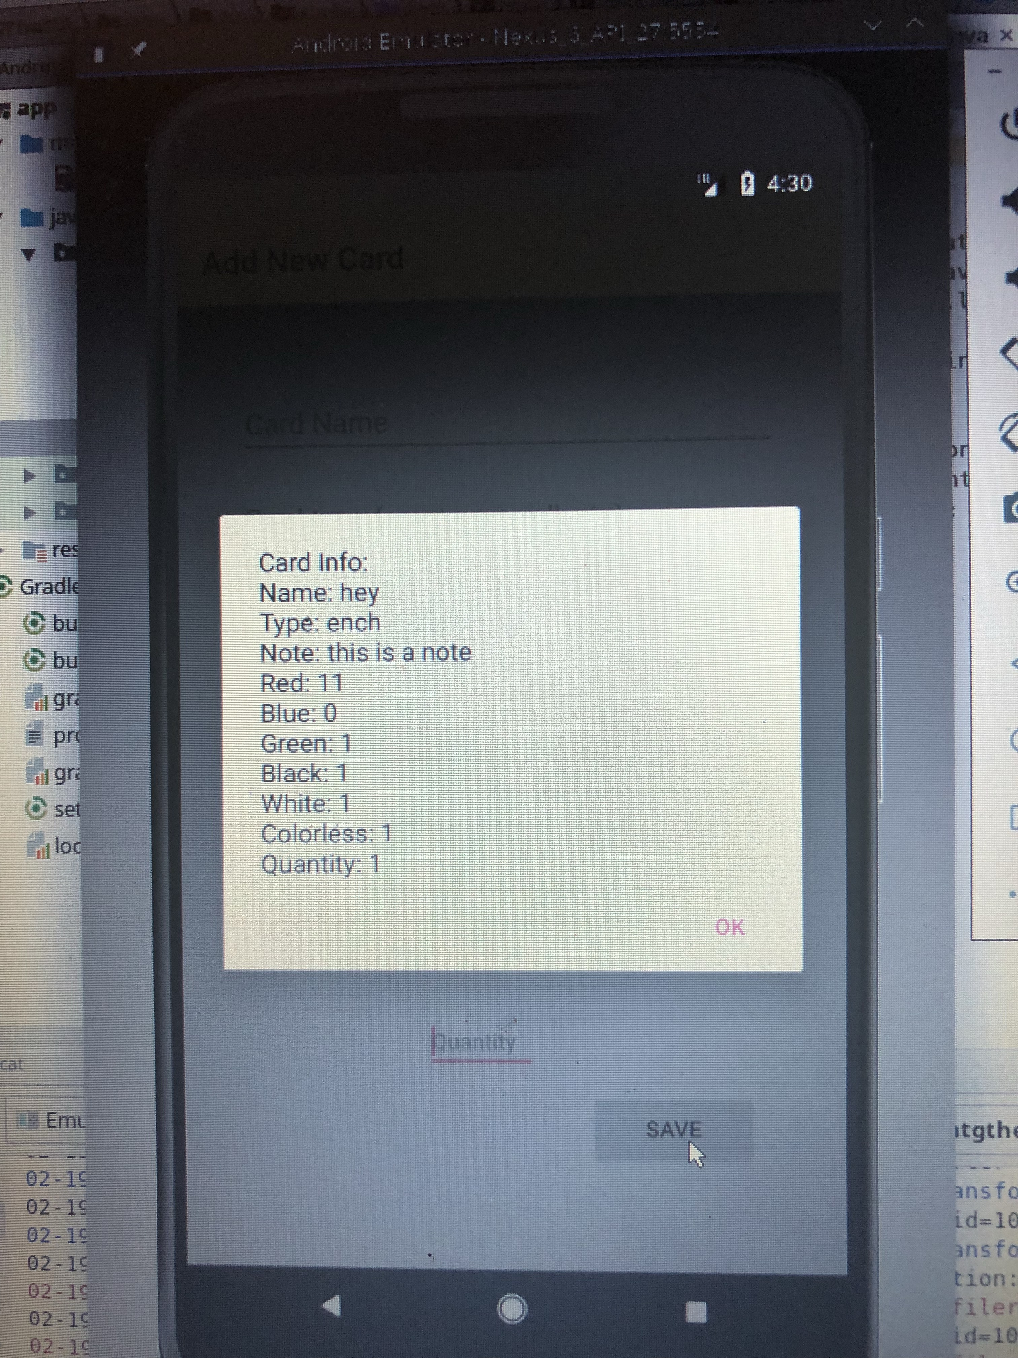

|  |  |  |  |
| --- | --- | --- | --- |
| **Story ID** | **Story / Task** | **Estimated**  **Hours** | **Actual**  **Hours** |
| S0 | Prototype full UI | 1 | 1 |
| S1 | Design the add card feature UI | 2 | 3 |
| S1 | Create actual database table(s) | 6 | 8 |
| S1 | Add relations between the tables | 3 | 0 |
| S1 | Implement all fields needed for add card feature | 5 | 3 |
| S1 | Connect DB to UI | 2 | 3 |
| S1 | Code save button  if time have system check information with user  might need to save task for later sprint | 3 | 4 |
| S1 | Design front page of app with just add button  but ensure space for all other options | 1 | 1 |
| Total |  |  | 23 |
|  |  |  |  |
|  |  |  |  |
|  |  |  |  |

Sprint review:

Currently only one table needed for functionality, so the need to create tables and add relationships was unnecessary. Otherwise, all tasks were completed. The system can add a card to the database. Currently it can be very slow and resource heavy. These issues will be addressed in next sprint.

Sprint Retrospective:

Officially, all goals were accomplished during this sprint. Every story included (that proved to be needed at this point) were included in the end of the sprint code. Comfort with XML files greatly improved between the beginning of the sprint and the end of it.

The most important improvement to make will be to research more first. Trial and error in the task of implementing a Room Database was very inefficient. Too much time was spent trying to figure out errors that could have been avoided with a bit more thorough research and planning. Moving forward I will focus more on having a full understanding of my task and my plan for executing it.

Sprint 2 Planning

|  |  |  |  |
| --- | --- | --- | --- |
| **Story ID** | **Story / Task** | **Estimated**  **Hours** | **Actual**  **Hours** |
| S1 | Improve speed of app when accessing Room | 5 |  |
| S1 | Create error message if Card lacks Name | 2 |  |
| S1 | If card already exists in DB at to the quantity | 4 |  |
| S1 | Add cancel if the user finds error in entered info | 2 |  |
| S2 | Design Search Page | 2 |  |
| S2 | Allow user to select a search by option | 4 |  |
| S1 | Use query to code delete button | 2 |  |
|  |  |  |  |
|  |  |  |  |
|  |  |  |  |

Sprint 2 Reflection

**Added Features:**

Enhancements to the add card feature:

*Check if card with same name exists in database: if it does update the quantity.*

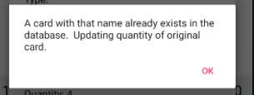

*Create error message if user tries to add a card without a Name. Preserve all other entered information and let user update the name and resubmit.*

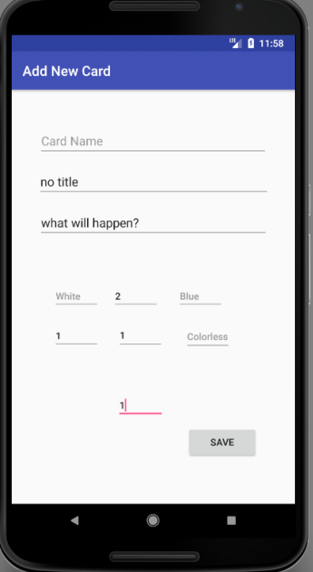

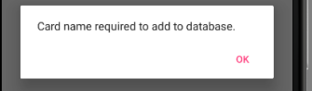

*Add delete button to home screen*

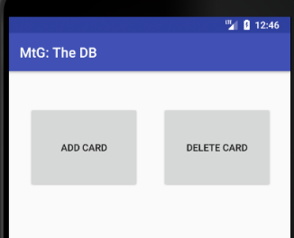

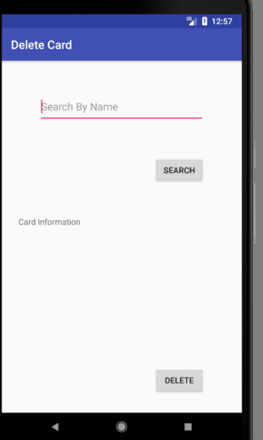

*User can search by name to bring up card information*

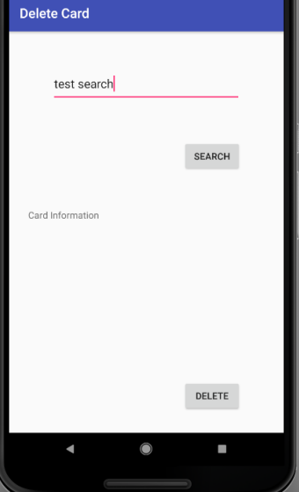

*If the card does not exist in the database an error message will display*

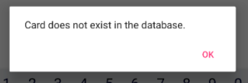

*If the card does exist information will populate on the screen:*

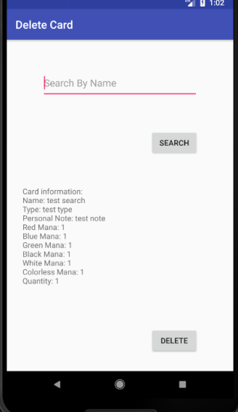

*User then selects delete and system deletes card from the database.*

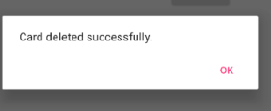

***Velocity*** *:*

Story 1 Complete : 15.

|  |  |  |  |
| --- | --- | --- | --- |
| **Story ID** | **Story / Task** | **Estimated**  **Hours** | **Actual**  **Hours** |
| S1 | Improve speed of app when accessing Room | 5 | 3 |
| S1 | Create error message if Card lacks Name | 2 | 6 |
| S1 | If card already exists in DB at to the quantity | 4 | 2 |
| S1 | Add cancel if the user finds error in entered info | 2 | 2 |
| S1 | Use query to code delete button | 2 | 8 |
|  |  |  |  |
|  | Total Hours: | 15 | 21 |
|  |  |  |  |
|  |  |  |  |
|  |  |  |  |
|  |  |  |  |

Sprint Review:

Story One is complete. I had to move tasks back to the product backlog due to other tasks proving to be much more time consuming than originally planned. Specifically, creating an error message if a card is entered without a name. There is a caveat in java that was not readily apparent. I spent a lot of time debugging why an error message would not populate inside of a loop. This is not a possible task in Java, so refactoring had to occur.

Rather than just having a simple delete button, I realized I wanted to have more of an interface surrounding the button so new functionality (as seen above) was added to accommodate a more user friendly card deletion experience. This increased time spent on delete functionality, but in the grand scheme creates a more user friendly experience.

Sprint Reflection:

During this sprint my primary goal was to research first and code later. I wanted my database access to be faster and safer (less crashes), I was able to both accomplish those goals, and understand why and where the crashes were likely to happen. I am quickly growing more confident and comfortable with the workings of the Room database, which will lead to much more efficient work throughout the process.

The large amount of design I added into the delete card process, shows that I need to spend more time fleshing out ideas and design plans. My original design, was complete, but it was not throughout enough. During the next sprint I need to create a more detailed plan and more UI mockups to avoid a large portion of implementation time being wrapped up in designing.

Sprint 3 Planning

|  |  |  |  |
| --- | --- | --- | --- |
| **Story ID** | **Story / Task** | **Estimated**  **Hours** | **Actual**  **Hours** |
| S0 | Flush out designs of future stories | 2 |  |
| S2 | Create search button on home screen | 1 |  |
| S2 | Implement search by name (allow wildcards) | 4 |  |
|  | Create new page for results | 2 |  |
| S2 | Implement browse by color | 4 |  |
|  | Create new page that allows user to scroll through all cards of a certain color | 1 |  |
| S2 | Implement Search by Note | 3 |  |
| S2 | Implement browse/search by type | 3 |  |
|  | Create new page that allows user to scroll through all cards of a certain type | 1 |  |
|  |  |  |  |
|  |  |  |  |